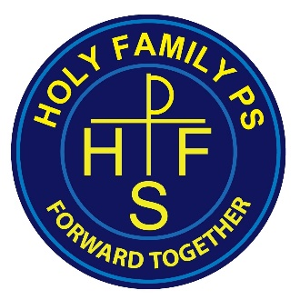
Procedure for a Pupil to follow if they wish to raise a concern

I can talk to my class teacher

I can talk to Mrs Mulholland – Designated Teacher for Child Protection

If I am still concerned, I can talk to Mr Mc Cormack - Designated Teacher for Child Protection

I can talk to an adult staff member in the school.

I can talk to someone at home.

I can call the NSPCC Helpline: 0808 800 5000

I MUST ALWAYS TALK TO SOMEONE!!

